**Al Imam Mohammad Ibn Saud Islamic University**

**College of Computer and Information Sciences**

**Information Technology Department**

|  |  |
| --- | --- |
| **Course Title:** | Web Systems |
| **Course Code:** | IT 390 |
| **Course Instructor:** | Dr. Amir Mohamed Talib, T. Shatha Alkhaldi,  T. Nora Alghamdi. |
| **Assessment:** | Project (phase three) |
| **Semester:** | First 2023 |
| **Due Date:** | Sunday 30 October 2022. |
| **Marks:** | 9 |

|  |  |  |  |
| --- | --- | --- | --- |
| **Group ID** | **Student Name** | **Student ID** | **Section No** |
| **2** | **Wadha almutairi** | **440020981** |  |
| Judy alzuhair | 440020665 |
| Yara almjudel | 440020360 |
| Fay altuwaijri | 441019791 |
| Jwaher bin-humaid | 441020896 |

|  |
| --- |
| There will be no extension in the submission deadline.  No late submission will be accepted. |

|  |  |  |
| --- | --- | --- |
| **Official Use Only** | | |
| **Question** | **Student Marks** | **Question Marks** |
| 1 |  | 9 |
| **Total** |  | **9** |

In this phase you will:

• Create the database.

• Fill the database with sample data.

• Create your dynamic (PHP) pages.

• Upload your website on your local server.

• Test your site (usability test)

A. Database

This is your database schema:

Admin (ID, username, password, email)

Category (ID, name, description)

Item (ID, name, logo, description, categoryID)

Review (ID, item_id, name, body, rating)

Notes on Database

• Underlined attribute: Primary Key.

• Dotted underline: Foreign Key.

• The item also has an overall_rating attribute but it is derived.

• Add any additional columns in the database that will support your website. For example: date, website, working hours, ...etc.

B. The functions that must be provided by your website:

Visitor functions:

• View all items (in home page or any other page specified for the

items)

• View an item (in the item profile page).

• View an item’s reviews (in the item profile page).

• Add a review to an item (in the item profile page).

Administrator functions:

• Log-in

• Add an item

* Item’s Name
* Item’s Description
* Item’s logo

• Delete an item

• Update (edit) an item

C. Dynamic Pages (PHP)

In your website, you have these dynamic pages:

Home page:

Contains a list of all the items in your website. Each item is a hyperlink that leads to

that item’s page. (Or you can put the items in another page such as “All_Items”

page so “All_Items” page will be the dynamic page)

Item profile page:

It contains the item name, logo, description and overall rating. At the end of the

item’s profile page, it lists all the reviews that belong to that item. In each review,

the reviewer’s name, the rating and the review body is displayed. At the end or top

of all reviews, there is an ‘Add your review’ form that enables the user to

insert new review which will be stored in the database.

Admin log-in page:

A form that enables the admin to insert their username and password. The form’s

action will retrieve the admin’s username and password from the database and

compares them to the inserted data, if they match, the admin is directed to the

control panel. If they don’t match, an error message is provided to the user.

The Admin Control Panel:

1. Add Item: contains a form that enables the admin to insert a new item’s

name, description, logo. The form’s action will insert the item to the

database.

2. Delete Item: A form that shows a list of available items, the admin selects a

certain item. The form’s action will delete the selected item from the

database.

3. Edit Item: Consists of two forms, first a form that shows a list of available items, the admin selects a certain item. The first form’s action shows the

item data in an editable form. The admin then can edit the existing text, then

clicks ‘edit’. The second form’s action will update the article that is already in

the database.

D. Usability test

You need to evaluate your site and test it on five different users, the users will

view your site and use it then fill the next table base on what they see.

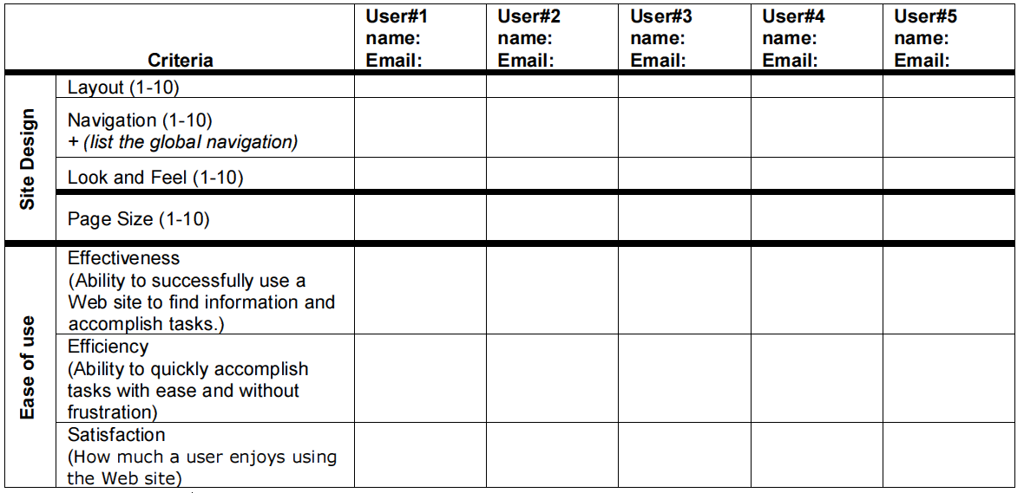

10

10

10

10

10

10

10

10

10

10

10

10

10

10

10

9

9

9

9

9

9

9

9

9

9

9

8

8

10

8

8

10

9

8

7

jawaher

wadha

yara

fay

Judy

Notes:

• You can change the wireframes or sitemap, but you should first notice the

teacher about that.

• The wireframes should reflect the final site.

• Modify the mistakes that occur in Phase#2.

• All your pages should use same or similar style, so that the pages look like they

belong to the same website.

• You should have a consistent navigation, for example if you have a menu which

links to different pages, the menu should appear in the same place in all pages,

so that users can easily find the menu and be able to navigate to different pages.

• You should organize all the pages in a good structure.

• Your pages should be easy to read, easy to navigate. The text, border,

background etc. should be contrasting, and don't use too many different colors.

• Use either an image map, or graphic images (buttons) for navigation links

• Appropriate use of graphics (at least one per page).

• External CSS file if it is repeated in multiple page.

• If you're using an image or some text from somewhere else, you must clarify the

origin of that resource in a comment in your HTML or CSS file, right before the

resource you're using.

• Arrange the project directory (folder for images, folder for pages and etc..).

• The home page of the site must be named index.html

• Appropriate use of Headings, fonts, color, text effects (bold, underlined, italics),

background colors or images.

Deliverable:

1. Your website should be uploaded to your local server.

2. A documentation with cover page containing students’ information (group

number, name, id, and section number) and a screenshot of all website pages.

3. If you have changed the Sitemap and /or Wireframes, upload the updated phase#2 on blackboard using phase#3 submission link.

4. All website files (your Database, HTML, CSS, PHP, JS, images, etc.) and the documentation should be submitted on blackboard.

**Submission:**

You should compress all your files into a zip (.zip) file and name like "project_<group-name>.zip, under "**IT390**", Delivers on Sunday 30 October 2022 where contain document include description about web site with print screen, and save the folder of project on CD, if not upload on internet.

Read the project description carefully.